

S-Mart Hiring Event Event Event

**S-Mart Hiring Event** 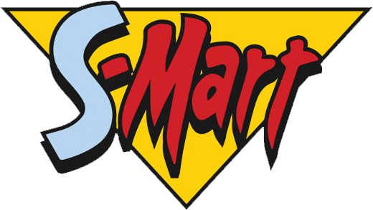

S-Mart Hiring Event May 1st 2019

700 S-Mart Way, Alma Michagan

Specialty Groceries